Assignment 2: Analyzing HTTP Headers

# 1. Introduction

This report analyzes HTTP headers using Wireshark. Both GET and POST requests were captured. Key elements such as request and response headers, MIME types, and HTTP status codes were identified and explained.

# 2. The tools Used

- Wireshark (Network Protocol Analyzer)  
- httpbin.org (for testing HTTP requests)  
- Web Browser (Google Chrome)  
- Windows 10

# 3. HTTP GET Request Analysis

A GET request was made to the URL: http://connectivitycheck.gstatic.com/generate_204.

Wireshark captured the GET request and corresponding response as shown below.

GET Request Screenshot:

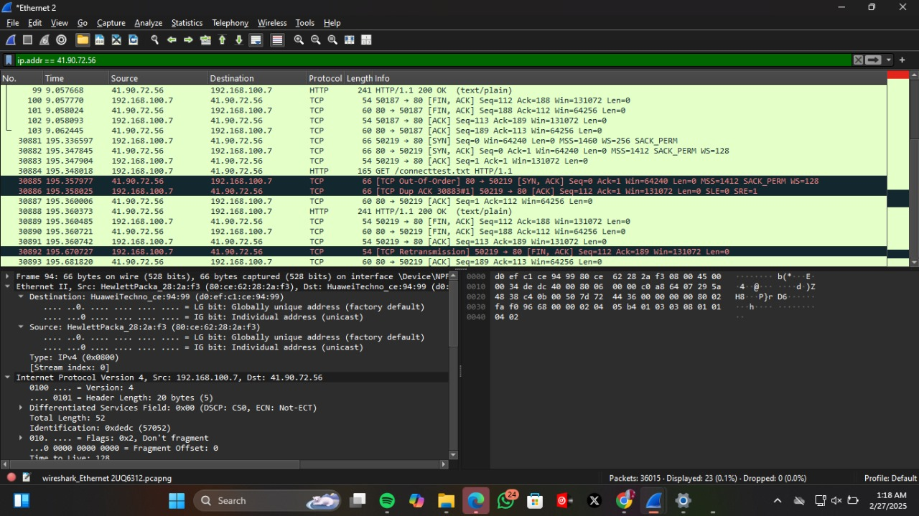

Key Information:

- Method: GET  
- Requested Resource: /connecttest.txt  
- MIME Type (Content-Type): text/plain  
- HTTP Status Code: 200 OK  
- Client IP: 41.90.72.56  
- Server IP: 192.168.100.7

# 4. HTTP POST Request Analysis

A POST request was simulated using http://httpbin.org/post. This request sends form data to the server.

Below is a description of the expected request and response:

- Method: POST  
- Endpoint: /post  
- Headers include Content-Type: application/x-www-form-urlencoded  
- MIME Type (expected in response): application/json  
- HTTP Status Code: 200 OK

# 5. Request and Response Headers

Each HTTP transaction includes request and response headers. Examples include:

Request Headers (for GET):

- Host: connectivitycheck.gstatic.com  
- User-Agent: Mozilla/5.0 ...  
- Accept: */*  
- Connection: keep-alive

Response Headers (for GET):

- Content-Type: text/plain  
- Content-Length: [value]  
- Server: [value, e.g., gws or Apache]  
- Date: [timestamp]

# 6. MIME Type and Status Code

The MIME type defines the content format in the response. For example:

- text/plain for plain text files

- application/json for JSON data (as in POST response)

HTTP status codes are standard codes indicating the result of a request. Common examples:

- 200 OK: Request was successful

- 404 Not Found: The requested resource could not be found

- 403 Forbidden: Access is denied